LOOKING DOWN THE HILL TOWARDS THE BOTTOM ROAD

Below: St. Canicus Cemetery, Mahanoy City, Schuylkill Co., PA. The plot stone with the cross in the lower right front of the photo has the name McCloskey on the front. The name is covered with grass. The white stone flat on the ground , mid picture on the left, is the McCloskey head stone. The white stone, in the center of the photo, is the base stone. The large grassy area in the lower front photo is the grassy road that is located in the middle of the cemetery. The Plot is located on the down side of the grassy road about 15 yards in from the road on the right. GPS: 40º 48’ .434” N - 76º 07’ .803” W

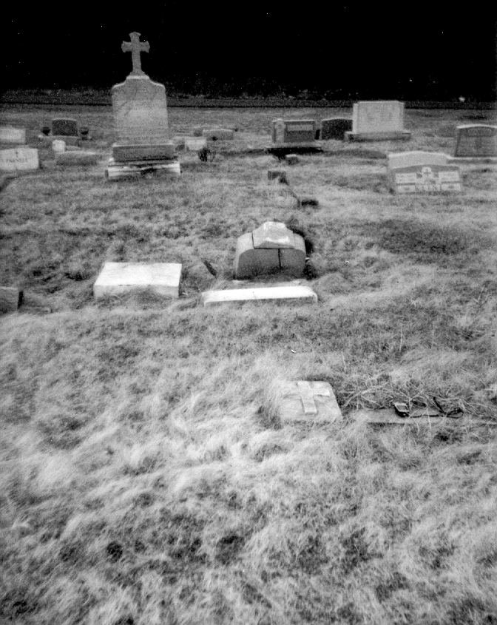
McCloskey Head Stone – Face Down

Base Stone

McCloskey Plot - Name Stone
There is a small square stone with an “M” on it located at the front of the plot.
Grassy Road In The Middle Of The Cemetery

Bottom Road of the Cemetery Hill

N E

W S

